www.pwarcham.cjb.net

Why MP3 Is Unacceptable As A Trading Format
(graphics and information provided by Brian Pasley)

With the popularity of MP3 exploding in the last 4 or 5 years, audio in this format has been about as tough to find as your left hand. People who can hardly even turn a computer on know the word MP3. It’s everywhere. This is all fine and good for checking out an artist before you buy his/her/their CD, or for casual listening every once in a while, but it should never, ever appear anywhere in the history of any music distributed in a trade. It is important to keep the integrity of the music we are sharing. The following is intended as a primer on the myth of MP3 sound quality.

Inferior Sound Quality

When MP3 first came out, everyone was all excited about this as the all-mighty new format. “It’s CD-quality Audio in one-tenth the file-size!” This is simply not true. There’s no such thing as a free lunch – the file size was cut to 9% or 10% at a cost. Sound quality is significantly degraded when transferred from CD Audio to MP3.

How They Do It

CD Audio is compressed into MP3 audio by throwing out all the sounds at the extreme ends of the frequency spectrum. In other words, they take out the high and low frequencies that they think maybe you won’t notice. To some extent, this is true – these are probably the frequencies you’ll miss the least. When this is done, you are left with an approximation to what the sound originally was. However, it is just an approximation. Though at a distance the song sounds the same, it is now missing something. To me, it may sound hollow or tinny. It just doesn’t sound quite right. While I may be enjoying the overall song as a whole, there’s something in my head that bothers me and tells me it’s not right.

The following visual spectral analysis graphs show this graphically. The degradation is quite clear in these plots.

Figure 1: WAV file Sound Level (dB) vs. Frequency (kHz)
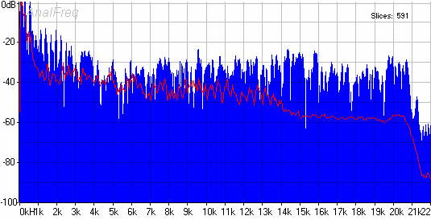

Figure 1 is a basic visual spectrum/frequency analyzer sample of CD quality audio in wav (lossless) audio format. The frequency in kilohertz is shown along the X (horizontal) axis and the sound level in decibels is measured on the Y (vertical) axis. The blue area represents "free run" (instantaneous) levels, while the red line shows long term average levels. Notice that the graph is fully populated from 0Hz all the way to 22kHz and beyond.
File: Radiohead's “Dollars And Cents” from the album Amnesiac
Source: CD audio
Type: extracted to wav format using Exact Audio Copy
File size: approximately 50 megabytes
Average dB: approximately -50dB
Frequency Range: approximately 0khz to 44.1kHz (only 0hz to 22kHz is visible above)

Figure 2: FM-Sourced Sound Level (dB) vs. Frequency (kHz)
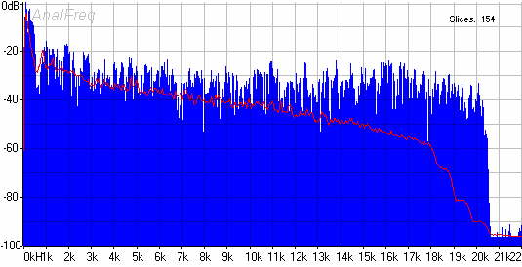

For the sake of general comparison, Figure 2 shows a basic visual spectrum/frequency analyzer sample of a piece of FM broadcast sourced audio, specifically Radiohead's “Dollars and Cents” as performed at Canal+ Studios and broadcast on BBC 1 radio extracted from the CD 'NP Amnesiac'. Note here that the graph is populated from 0Hz all the way to about 20.5kHz, which is about the extent of most humans’ hearing capacity.
File: Radiohead’s “Dollars And Cents” performed at Canal+ Studios
Source: CD audio from FM broadcast
Type: extracted to wav format using Exact Audio Copy
Filesize: approximately 48 megabytes
Average dB: approximately -50 dB
Frequency Range: approximately 0khz to 20.5kHz

Figure 3: MP3 File Sound Level (dB) vs. Frequency (kHz)
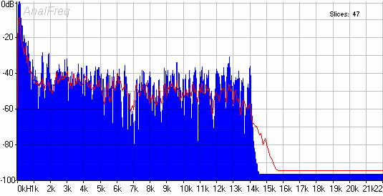

This is the money shot. Figure 3 is a basic visual spectrum/analyzer sample of the same original segment of CD quality audio after being encoded into mp3 format (lossy). Note the absolute lack of any sound levels above about 14kHz. This appalling absence of the upper frequencies is what degrades MP3 audio so much. While the song sounds roughly the same, it is left without the same sound as it was originally intended to have – it has lost its fullness. While the spectral analysis of the WAV file was fully populated, the MP3 file is severely reduced and lacks a large part of the original sound.
File: Radiohead's “Dollars And Cents” from the album Amnesiac
Source: CD audio
Type: extracted to mp3 (lame type) using easy cd-da extractor
Filesize: approximately 5 megabytes
Average dB: approximately -60 dB
Frequency Range: approximately 0kHz - 15kHz

What This All Means

When comparing the file size of the CD and FM sourced audio samples, it is clear that the two files are basically the same size. However, when comparing the visual spectrum/frequency samples of the CD audio and the CD audio sourced from an FM broadcast, it becomes abundantly clear that the sound levels of the FM broadcast cut off completely after roughly 20.5khz while the CD audio does not. Many scientists estimate the hearing threshold of the human ear to be between 20hz and 20khz (I personally have tested myself to be able to hear to about 23.5kHz). This is why the visual sample of the FM sourced CD audio file clearly cuts off at just after 20.5khz. Including any sound above the 20khz range would require more advanced and expensive broadcasting and reception equipment and would be completely unnecessary as it would be beyond the range of most human hearing. However, discarding any sound information under this 20khz range is not desirable - though it would result in smaller and more convenient file size, it would eliminate necessary sound information and decrease sound quality. This is, unfortunately, exactly what the mp3-encoding format does.

By comparing the file size of the WAV file extracted from Amnesiac and the MP3 file extracted from Amnesiac, it is clear that the size of the MP3 file is significantly smaller than that of the CD audio file in WAV format (roughly a tenth). This in fact is the very reason the MP3 format was created - in order to convert large audio files into smaller files that could be more easily distributed over the internet. However, by comparing the visual spectrum/analyzer samples of both the CD audio and MP3 files, it becomes crystal clear that this smaller file size is accomplished by "discarding" much of the audio information, specifically any information above the 16khz range. Again, many scientists estimate the threshold of the human ear to be between 20hz to a little more than 20khz. So, while the FM broadcast sourced audio cuts off at just over 20.5khz, which doesn't affect audible sound quality, the fact that mp3 sourced audio cuts off at around 16khz does affect sound quality as necessary sound information is discarded in order to maintain smaller and more convenient file size.
In the end, in terms of sound quality, audio sourced from FM or television broadcast is suitable for trading, while audio sourced from MP3 is not.

The Principle of the Whole Matter

There is no acceptable reason to trade for recordings in an inferior audio format (MP3).

If you are going to go through the work of buying CD -Rs, finding another trader to trade with, burning shows, and mailing them, you might as well end up with the best quality recording you can find. I know I expect nothing less. No show has ever been bootlegged in MP3 format, so these better quality recordings definitely exist. If I find a trader who has a show I want, but it is in mp3 format, the only conceivable reason he has the show in MP3 format is because he does not have the better quality original recording, but instead something he probably downloaded off the internet. If this is the case, I could save myself a trip to the post office by downloading the show from the internet myself. For some strange reason, most people with MP3 shows expect you to go through the trouble of trading with them instead of telling you where they downloaded the show so you could download it yourself -probably because they are a middleman and if you realize that they are unnecessary, they don't get anything. They’re trying to rip me off.
If, for some ungodly reason, the trader is offering me an MP3 show, but has a non-MP3 version of the show (what kind of moron would do this?), I would just trade for the non-MP3 version, as MP3 is an inferior, diluted audio format. If I still want the show, but don't want an MP3 sourced show for the above reasons, with just a little more effort, I can find traders who don't deal with MP3, and even if I don't have any non-MP3 sourced shows to offer them, they are usually willing to do 2:1 trades or a B&P.

Now, even though I just explained this all to you, if you don't mind an MP3 sourced show, there is still no reason to go through the trouble of trading for the show, as MP3 shows are freely available for download on the internet.
In the end, there is no reason to trade for an MP3 sourced show.

How To Check For MP3-Sourced Shows

If you would like to test these results for yourself, or would like to determine if one of the concerts you have is sourced from MP3, it's actually quite easy. Just follow these two simple steps:
1: Extract a track from the show onto your hard drive in WAV format (I recommend using Exact Audio Copy, the highest rated program of this type among traders, and the most accurate audio grabber available anywhere, which can be downloaded for free here).
2: Open the WAV file using a spectrum/frequency analyzer (I recommend Analfreq v1.80, which can be downloaded for free here or here). If the sound levels cut off after 20.5khz, the show is sourced from an FM or television broadcast (which is acceptable). If the sound levels cut off around 16khz, the show is MP3-sourced (which is not acceptable).

Home

Thank you to Brian Pasley, who provided the graphics for this page and much of the information found here.
His web site can be found here.

