a l l a b o u t e v e
biography
Julianne Regan, Andy Cousin, Toni Haimi, Ben Savigear
www.allabouteve.net

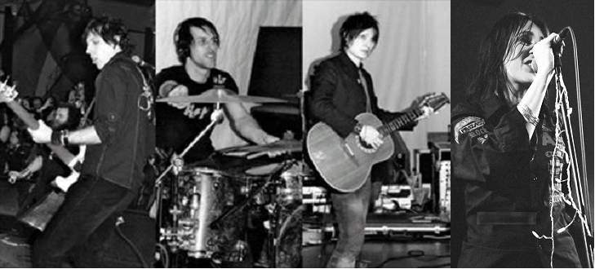

Andy Cousin, Ben Savigear, Toni Haimi, Julianne Regan.

MARCH 6th 2006

Release of e-single Keepsakes to promote retrospective collection of the same name.

MARCH 13th 2006
Release of KEEPSAKES 2 x CD album and limited edition DVD

Prior to this…

The single LET ME GO HOME was released in the UK on May 24th 2004 and entered the Official Indie Chart at number 7. Format 2 features cover of the Cure’s ‘Apart’.

1 9 9 2 to 2 0 0 2

All About Eve split in 1992 but re-formed (briefly with Mark Price back on drums but who since joined Right Said Fred (!) and then Scotland’s Del Amitri), in late 1999, and played three shows supporting old chums The Mission. They then began to play acoustic shows at venues such as Liverpool’s Neptune Theatre, The Leeds Varieties Playhouse, and Ronnie Scotts.
Since 1999, they released two volumes of live acoustic recordings, and also released a live electric album from their sell-out Christmas 2000 show at London’s Union Chapel. In December 2001, they repeated their sell-out of the Union Chapel. They will play the Union Chapel again in December 2003
They did an electric tour of the UK in May, showcasing songs from which were to appear on their first studio album for a decade. Prior to the tour, the band parted company with guitarist Marty Willson-Piper due to the age-old adage of ‘musical and personal differences’! Willson-Piper was replaced by Toni Haimi who had been in NME-hopefuls ‘Malluka’ and also in Nozzle (with Dave Blomberg of New Model Army and Dance on Glass) and prior to that, in Finland’s cult band, ‘Lowdown Shakin’ Chills’.

NME on Toni Haimi…”Thankfully, Malluka are free of the patchouli'n'panstick nightmares of yore. Malluka are goth, like Joy Division or Girls Against Boys were goth - not in the details, but in their morbid romanticism, the scorched-earth bareness of their sound, the way they fetishise being pale, skinny and intense. Were Malluka a great deal less subtle, less earthy, they'd be Placebo. Guitarist Toni Haimi looks like a young and - impressively - more sinister Jimmy Page, alternating between noose-tight rhythm lines and loose, flowering solos with ease.

Christmas 2002

The band release ‘Iceland’, through their website only… a themed Winter album comprising new compositions alongside covers of Last Christmas by Wham and A Winter’s Tale by Queen. It received very favourable reviews on many Internet publications and also in Uncut magazine.

2 0 0 3
All About Eve embarked upon a UK tour from April 3rd through to May 3rd. Drummer Del Hood had to leave the band due to his ‘geographical re-location’ (!) and was replaced for this tour by the colourful powerhouse that is Robin Guy (ex of cult Glamsters Rachel Stamp). Robin also has a few Summer festivals with Bruce Dickinson on his C.V!
"Robin’s usual tireless self and showmanship come as a welcome break. “Metal Hammer"
“One British drummer determinedly keeping showmanship alive “ Rhythm Magazine

AAE’s drummer situation took another Spinal Tap turn when Robin Guy had a clash of commitments and had to go out on the road with Martin Grech (car advert man!) just as the Eves needed him. Very amicably, Robin put the band in touch with the man who was to be his replacement. Ben Savigear.

A live DVD and CD ‘Cinemasonic’ was released to coincide with tour
(Contains 18 tracks and 6 new songs and a majestic cover of Bowie’s Life On Mars
and 15 minutes of candid footage. Also an 11 track CD released for those not yet DVD’d up.

WHITBY GOTHIC WEEKEND NOVEMBER 2003
All About Eve headlined the final night of the WHITBY GOTH WEEKEND

"All About Eve? I'm astonished to find myself saying this, but they were absolutely storming. I've cordially disliked AAE ever since their hippy days, and I fully expected them to deliver a set of weedy folkiness at Whitby. But that set was PUNK ROCK! Masses of energy and humour, rip-roaring guitar-work (you can't beat a soundly thrashed Gibson Les Paul, that's what I say), and Julianne dropping in the one-liners like she was doing stand-up. “

SOLO and COLLABORATION

Julianne Regan has been involved in various side-projects, having worked with members of The Dream Academy (best known for Number 1 hit ‘Life In A Northern Town’), Jah Wobble, The Mission, Ireland’s critically acclaimed ‘darkwave’ band This Burning Effigy, Bernard Butler of Suede and Japanese art-rockers Schaft. She released a solo album under the guise of a band called ‘Mice’ in 1996, critically acclaimed but deemed at the time to be too much of a departure from her roots by the All About Eve audience. Now re-released under the title ‘New & Improved’, it is enjoying more success.
With Jean-Marc Lederman, a friend from the early line-up of Gene Loves Jezebel that Julianne was in before she formed All About Eve, she has a project called Jules et Jim and has released a mini-album of sophisticated electro-pop, called Subtitles. This is to be followed up with an album of covers and the second Jules et Jim album proper.

Andy Cousin, having once spent a 3 year stint in The Mission, masterminded a successful project called The Lucy Nation who contributed a song to the multi-platinum selling soundtrack to the last Austin Powers film and were signed by Madonna’s Maverick label.
Tony Haimi
Is now (January 2006) the guitarist in The Sohodolls who have just signed to Alan McGee’s label, Poptones. They have been described as ‘Ladytron pretending to be the Sugababes.’ Sounds good to us.

JANUARY 2006

All About eve had ‘kind of ‘split up. They always ‘kind of’ split up but never seem to actually be able to split up! The recording of the ridiculously long-awaited and very difficult fifth album was shelved but the tracks are now being dusted off and new tracks being written. The release of the retrospective collection Keepsakes, due out on Universal on March 13th 2006, has sent doves of peace flying around the surprised heads of ex members and current members and so who knows where it will all end? The blissfully clueless members of All About Eve can’t even answer that one!

