Artwork by Storm Thorgerson

Audioslave – 2002

The cover to the Audioslave CD was inspired by Pink Floyd’s live recording in the ruins of Pompeii, Italy in 1971. Thirty years later, Storm returned to the site to work on a DVD version and of Pink Floyd Live at Pompeii and the artwork for Audioslave began to take shape.

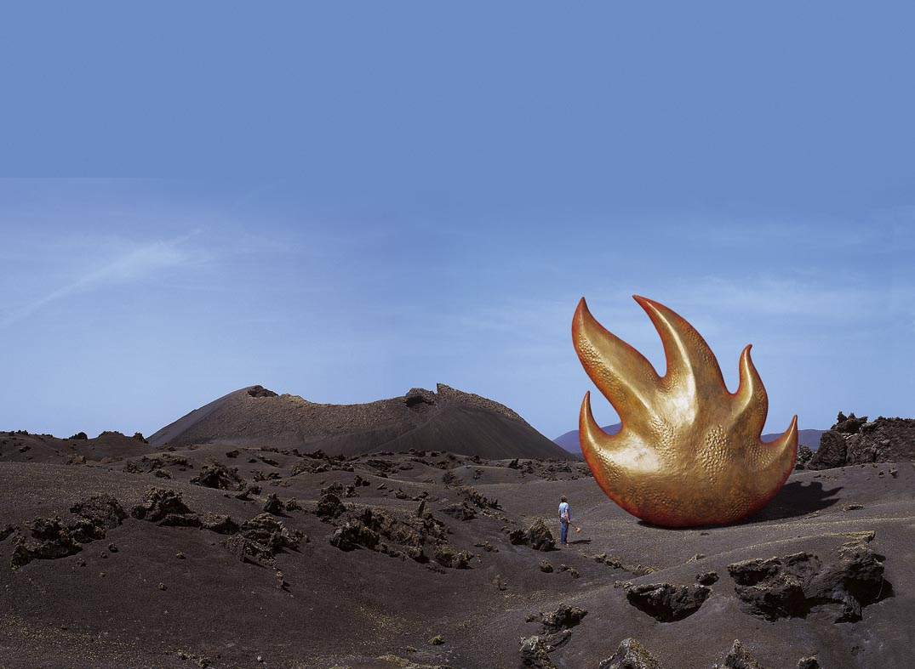
Compliments of Storm Thorgerson

“Work begets work, ideas spawn further ideas. We had been working on a Live at Pompeii DVD and were very preoccupied with volcanoes. The sultry rock music of Audioslave seemed to suit the brooding power of volcanoes. At first we didn’t know what to do until we came up with a graphic flame like an eternal flame in a shape that looked like a hand of flame, which we turned into a large sculpture make of beaten bronze, like a sounding brass. This sculpture sitting majestically in a volcanic landscape is being honoured by a pilgrim, a slave to sound (Audioslave) paying homage as any slave should.” – Storm Thorgerson, private interview, 2004

