Artwork by Storm Thorgerson

Bury the Hatchet - The Cranberries –1999

The Cranberries cosmos is reflected beautifully with the diptych images used for “Bury the Hatchet”. Two themes are represented in this picture: that someone may always be watching (eg big brother, surveillance, terrorist measures) and the internal eye of guilt and paranoid (one’s conscious). In this particular image, the ‘dreaded eye of paranoia’ is hovering over the naked and vulnerable figure. Afraid and pressing down on him with nowhere to escape, the figure covers his head to hide but the eye is still watching. The second image (not shown) illustrates the same figure standing facing the eye, screaming in retaliation and fighting back. We may not be able to escape the all-seeing eye, but we can tell it to fu*k off when we want to!

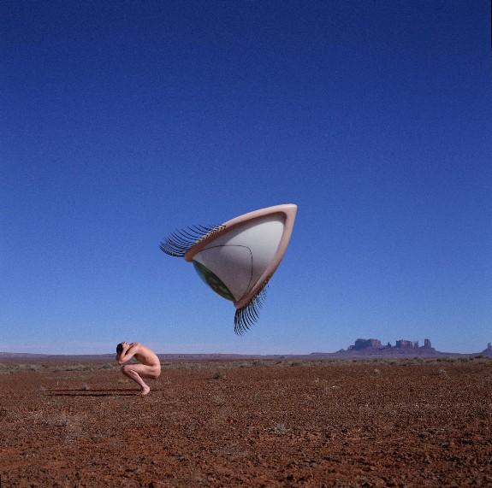
Compliments of Storm Thorgerson

“When we arrived in Flagstaff it actually snowed. Couldn’t believe it. Miraculously the weather cleared further north, providing two glorious days of perfect winter light. On location on the first morning our truck broke down in the middle of nowhere. We got the Navaho heebie jeebies about working on what might be the sacred land, and with what exactly? An evil eye and a naked man! Should be easy to explain (especially to a Navaho). And then we were caught speeding twice.” …”—Storm Thorgerson, “Eye of The Storm: The Album Graphics of Storm Thorgerson, Sanctuary Publishing,1999

