Artwork by Storm Thorgerson

The Division Bell – Pink Floyd – 1994

The Division Bell was the first new Pink Floyd album since Momentary Lapse in 1987. A major theme of the album was of contradiction in communication – the distinct presence of it and lack of it. Storm’s aim was to create an image that expressed these directly conflicting views. After thrashing around a number of ideas, the Division Bell was born. One will see two heads looking at each other while another will see a single head face-on. This clever illusion is contradictory. Both visualisations are rarely seen simultaneously. The beauty of this image is that everything you see in the photograph is real – the metal heads, cathedral, skyline and landscape … all are real (and without computer manipulation), especially the sculptures made as high as a house.

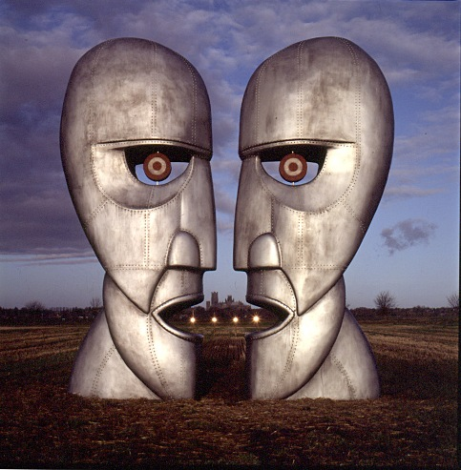
Compliments of Rock Optic

“Contradictory communication. For example, there are bells to alarm as in clock, and bells to celebrate, as in church. There are bells to summon, as in school meals, and bells to warn, as in bicycle. The Division Bell itself is rung to bring Members of Parliament together so that they can be not together, ie divide when voting. More contradictions.” -- Storm Thorgerson, “Mind of Matter”, Published by Sanctuary Publishing Limited, Third Edition, 2003.

