Artwork by Storm Thorgerson

Kindred Spirit – Nigel Kennedy – 1995

Fritz Keiser was a classical violinist of the 20’s and the 30’s, admired and adored by all. A composer and performer, he played beautifully and original pieces that were simply amazing. Inspired by Keiser, Nigel Kennedy – himself a musical genius -- produced an album of Keiser tracks and concert pieces called “Kindred Spirit”. The result was nothing short of a beautiful masterpiece of music. The album cover was cleverly designed around the twin muses in Keiser’s life, representing playing and composing; they take shape in the female form. The silhouettes are connected to a male figure, the source itself. Like strings on a violin, all the figures are attached by strings. These symbolise the connection and the commitment to the source. This particular image never made it to the album cover.

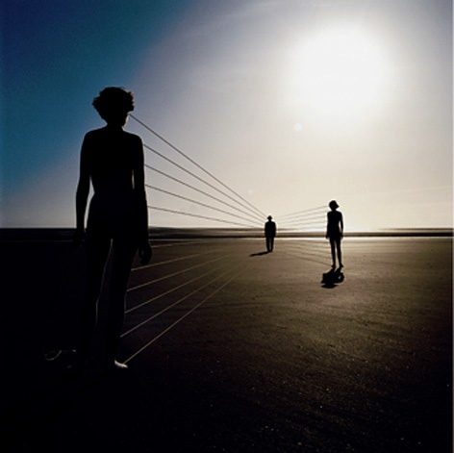
Compliments of Rock Archive

“The cover was finished, and even proofed, but the record itself was shelved indefinitely…and then in ’98, just as predictably, he changed his mind and released the album after all. However he replaced my picture with a photo of himself, the swine…”

