Artwork by Storm Thorgerson

A Momentary Lapse of Reason – Pink Floyd – 1987

The inspiration for this photograph was from the song ‘Yet Another Movie’ which had as part of its lyrics ’A vision of an empty bed’. Inspired, Storm had the idea of arranging seven-hundred Victorian hospital beds in a slight curve stretching away from the camera like a ‘river bed’. These were envisaged as beds that mad people, ill people or even dreamers may occupy. After setting up the installation (or ‘exstallation’ as we like to term it), it began to rain, turning grey and producing limited visibility. Storm and his team had to pull the photo-shoot, pack up shop and return two weeks later (after carefully assessing the weather) to take the photograph you see now.

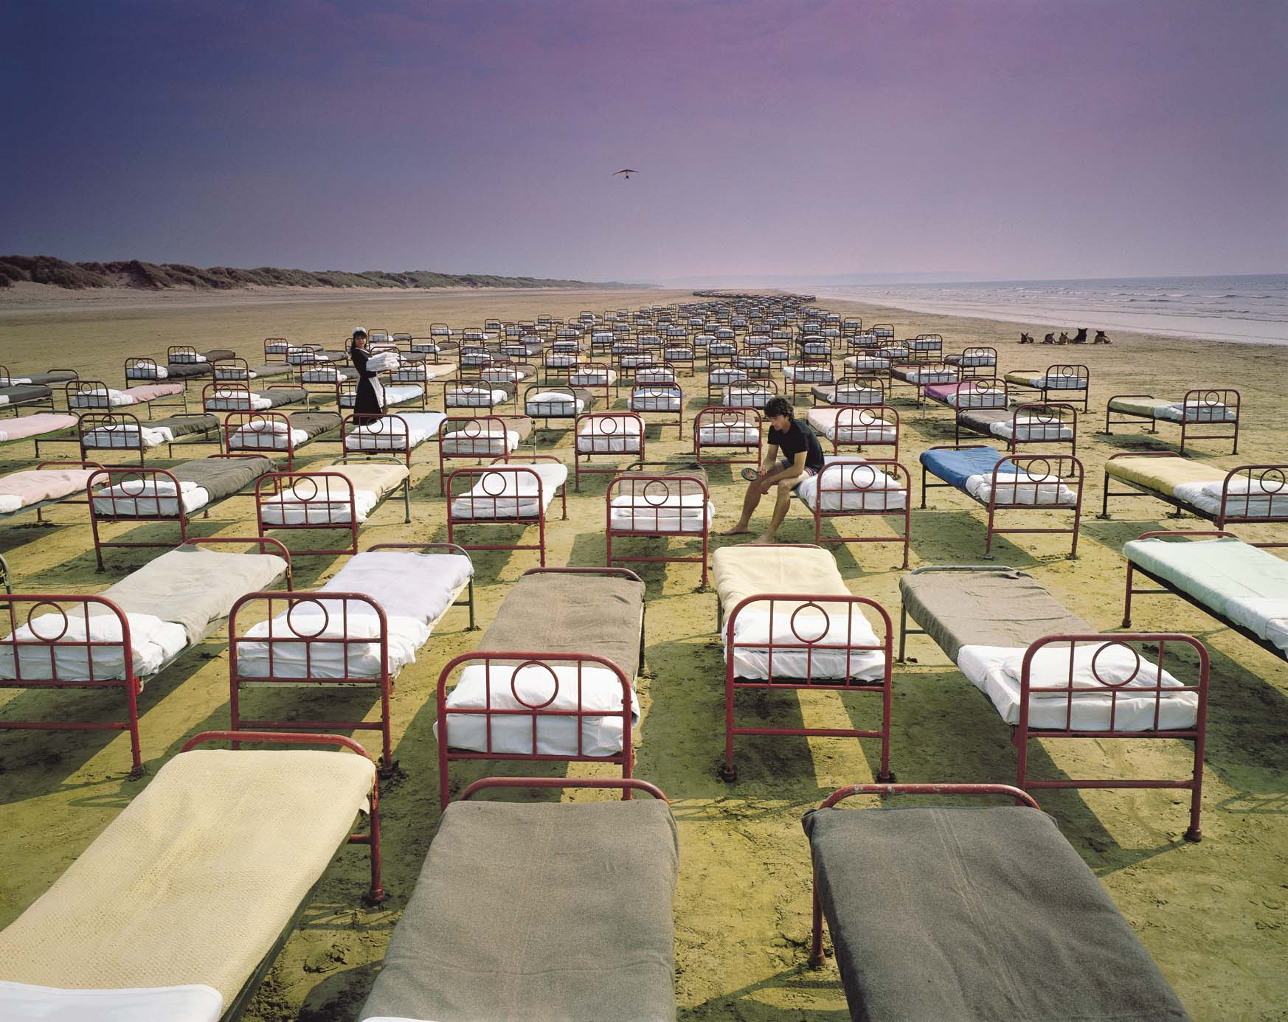
Compliments of Rock Optic

‘What you get is what you see: 700 wrought iron beds all individually made up and each weighing several tons, or so it seemed by the end of the day. The photograph …is a 35mm colour transparency taken when the tide was on the turn and came rushing back, flooding all the beds in the blink of an eye. Wet dream, or what.” -- Storm Thorgerson, “Mind of Matter”, Published by Sanctuary Publishing Limited, Third Edition, 2003.

