Artwork by Storm Thorgerson

Mr Lovepants – Ian Drury & The Blockheads – 1998

After a 17-year break, Ian Drury returned and unleashed “Mr Lovepants”. Initially christened “Different Strokes”, “Mr Lovepants” found his way to Ian Drury and the rest is history. Almost automatically, Storm had an image in mind…. vivid, bright beaches and a boxer dog! The dog was photographed several times at various locations and in a collection of different designer shorts. The image of the dog was then dropped into a Caribbean background, with artwork of the plane and boat crashing at sea added behind him. Amongst the mayhem, our dog smiles on.

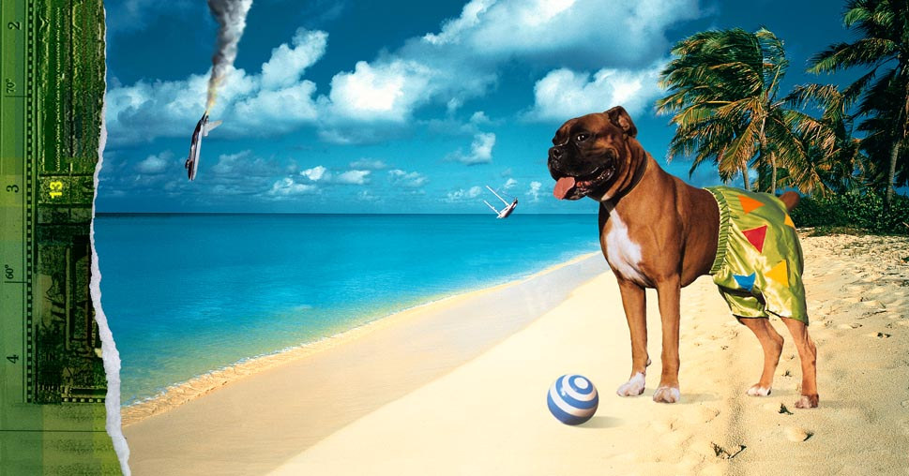
Compliments of CCA Galleries

“…It was the dog’s expression which was crucial. It makes me smile to this day, for there he is grinning at us with quivering nostrils and lascivious eyes, dressed to kill in bright shiny green boxers, as only a boxer should, standing nonchalantly on a beach in Bermuda (as in Bermuda shorts), decorated with triangles (as in Bermuda triangle) and panting (with love) in true boxer style…”—Storm Thorgerson, “Eye of The Storm: The Album Graphics of Storm Thorgerson, Sanctuary Publishing,1999.

