Artwork by Storm Thorgerson

Wish You Were There – Pink Floyd (Single) – 1995

The inspiration for the artwork for this US single stemmed directly from the words of the lyrics, which referred to two lost souls swimming in a fish bowl. The photograph is of a couple looking through two separate fish bowls. Although they are side by side they are apart, swimming alone in their individual bowls. Their faces are distorted to expose grim and severe dispositions. This image is a man-made creation (without any use of computer effects). The best description of this piece comes directly from Storm.

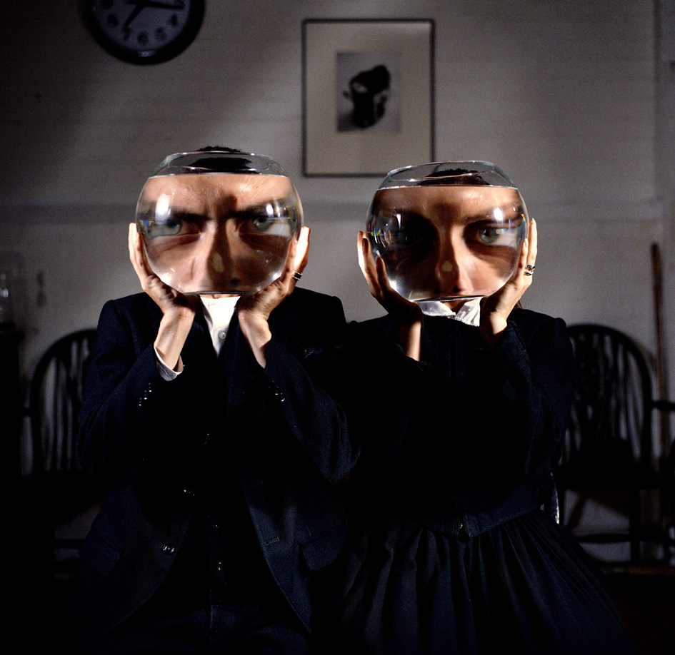
Compliments of Rock Archive

“A dour couple, their faces trapped in a world of their own, confined within the fish bowls, intense and distorted in their separateness. No retouching here, no clever tricks, not pretence. Like the words of the song.” -- Storm Thorgerson, “Mind of Matter”, Published by Sanctuary Publishing Limited, Third Edition, 2003.

