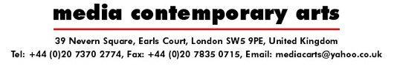

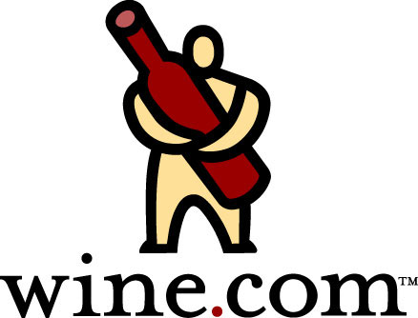

FOR IMMEDIATE RELEASE
8th April 2005

Media Contemporary Arts and wine.com are delighted to announce the travelling exhibition of “Taken by Storm: Art of Storm Thorgerson”.

Storm Thorgerson, first with Hipgnosis and then later in his own right, is the artist behind the images synonymous with identifying the pop culture of the 70’s throughout and into the Millennium. Creating visually beautiful and thought-provoking art, Storm’s work has featured on a variety of single and album covers and collected in books including “Eye of the Storm”, “Mind over Matter” and “Walk Away Renee”. Storm’s distinctive style has made his artwork one of the most recognisable in the music industry. He is responsible for the iconic images we associate with bands like Pink Floyd, Led Zeppelin, Peter Gabriel, Ian Dury and The Blockheads; and more recently bands such as Audioslave, Mars Volta and Anthrax.

The distinctive and edgy style of Storm Thorgerson’s work has an element of “performance” to it. Storm takes joy in engaging the audience to provoke a reaction through ‘temporary installations’ captured by the camera – is it reality or is it fantasy?

I like photography because it is a reality medium, unlike drawing which is unreal. I like to mess with reality. Bend reality. Some of my works beg the question of is it real or not? I use real elements in unreal ways. Is the man really on fire? Why would he just be standing there? Who put the beds on the beach? Why? Why is there a cow on the cover? It doesn’t have anything to do with the album, or does it? A boxer dog in designer boxer shorts on a beach?

Incongruity. I like to create things that are unlikely (dog in designer shorts), unbelievable (beds on a beach) and unacceptable (setting a man on fire). Make people doubt what they see. How real is real? My work triggers sufficient interest in what it ‘is’ and makes people ask what it ‘means’. – Storm Thorgerson, July 2004

Following the successful 2004 London debut, this travelling exhibition will be the first international exhibition of Storm’s artwork since his stroke during the opening night of his Paris exhibition and the first ever US exhibition dedicated to his work.

The US tour of “Taken by Storm: Art of Storm Thorgerson” will be in Chicago May 6th – June 5th at Inspire Fine Art (www.inspirefineart.com) and will then be part of the ‘Art in Music’ exhibition at Forest Lawn Museum (www.forestlawn.com) July 31st – October 9th before continuing to other USA cities in 2005/2006. Wine.com will be providing a tasting of premier wines from some of the world’s greatest wine regions at gallery events. Please refer to www.takenbystorm.us for the most up to date information on the tour including cities the exhibition will visit and special events throughout the tour.

For a press pack, further information or to request an interview with Storm Thorgerson, please contact:

Nina Naran Robin Headlee
Nina@mediabitch.com Robin@mediabitch.com
+44 (0)7956 841 359 +44 (0)7799 034 710

Media Contemporary Arts is a division of Media Bitch™.

