Press Information - Monday 5 September

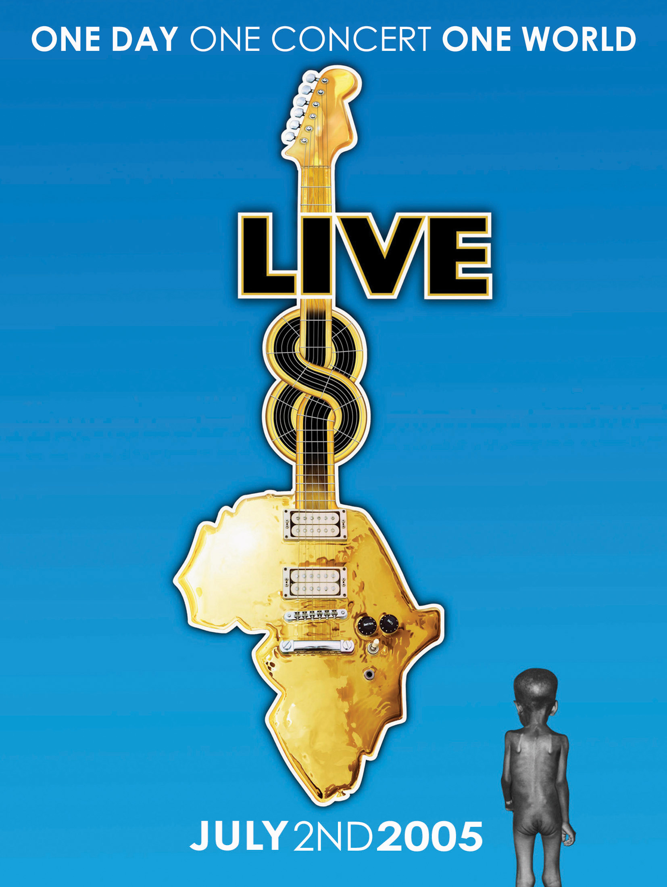

THE GREATEST SHOWS ON EARTH
TO BE RELEASED ON DVD

EMI are proud to announce
the DVD release of Live 8
7 November 2005 (8 November 2005 – US)

On 7 November 2005 (8 November 2005 – US) the biggest live event DVD project of its kind will be released. Live 8 brings together performances from the amazing series of concerts which took place around the world on 2 July 2005.

Live 8 – One Day One Concert One World

The 4-disc set contains three discs of live footage taken from the Live 8 shows staged in London and Philadelphia alongside key highlights from the seven other events staged across the world. Every artist who performed at London’s Hyde Park and Philadelphia’s Museum Of Art appear on the DVD, many of them with their full sets.

“It was 20 years ago today…” Live 8 opens with U2 and Paul McCartney’s crowd-rousing rendition of Sgt. Pepper’s Lonely Hearts Club Band and also features Pink Floyd’s historical reunion, Robbie Williams’s show-stopping performance and Madonna’s breathtakingly energetic set. Younger artists such as Snow Patrol, The Killers and Joss Stone comfortably intertwine with rock n’ roll legends such as The Who and Sting. One-off duets come from Paul McCartney and George Michael, Stevie Wonder and Adam Levine (Maroon 5), Elton John and Pete Doherty and Coldplay and Richard Ashcroft. Disc 3 closes as the London concert closed on 2 July with the stars of Live 8 Hyde Park taking to the stage for the stunning ‘Hey Jude’ finale.

Along the way the Kaiser Chiefs waved the flag for Britain in Philadelphia and their vigorous performance is captured alongside American superstars Destiny’s Child, Bon Jovi, Black Eyed Peas and soul legend Stevie Wonder.

Also threaded through the UK and US acts are performances from artists who appeared at the Live 8 concerts in Rome, Paris, Berlin, Toronto, Johannesburg and Moscow. Tracks from Green Day, Brian Wilson and Roxy Music in Berlin and Neil Young in Toronto are included along with the Pet Shop Boys in Moscow, Duran Duran in Rome, Vusi Mahlasela in Johannesburg and Placebo and Muse in Paris.

Disc 4 features exclusive extras including a never-before-seen backstage documentary filmed at Hyde Park, Pink Floyd’s Live 8 reunion rehearsal, more acts from Live 8’s global concerts including McFly and Bjork in Tokyo, films by The Who and Travis and a contribution from Ricky Gervais.

The special features section will offer highlights from Edinburgh’s Final Push concert at Murrayfield on July 6 which will include performances from James Brown, Travis and The Proclaimers.

Single disc sets for the French, German, Italian and Canadian Live 8 concerts have also been produced. These will focus further on each country’s concert and will be available globally.

“I hope this will be the biggest selling DVD of all time. It deserves to be. More importantly perhaps, it should be, for it will help us achieve our goal of changing the lives of the extreme poor for the better and making our generation the one that helped end the disgrace of poverty.” Says Live 8 organiser Sir Bob Geldof.

Money raised from sales of the Live 8 DVD will go to the Band Aid Trust for the relief of hunger and poverty in Africa.

Live 8 was held on 2 July 2005. Nine simultaneous, free concerts starring the cream of international rock and pop artists were staged in London, Paris, Berlin, Rome, Tokyo, Moscow, Toronto, Johannesburg and Philadelphia. The concerts acted as a starting point for The Long Walk To Justice in support of the Make Poverty History and Global Call To Action campaigns and was timed to focus attention on the critical decisions made by the G8 summit four days later.

“You’re such a lovely audience, we’d like to take you home with us” sang Bono. Now the million-strong live audience and 5 billion viewers around the world can take Live 8 home with them…

www.live8livedvd.com

For further information please contact:
LD Communications - 020 7439 7222
Print: Rachael Wright - rachael.wright@ldpublicity.com
TV & Radio: Maria Barham - maria.barham@ldpublicity.com

