All About Eve
Keepsakes - A Collection
Release Date - 13th March 2006
e-single of title track released 6th March.
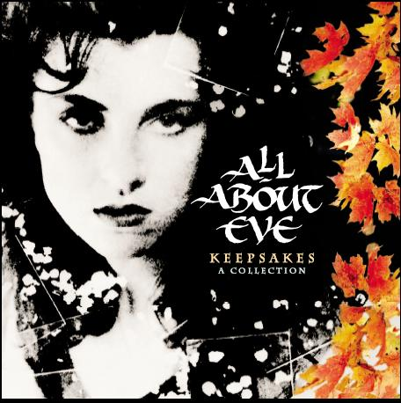



The 1980s have long been regarded as a musical catastrophe, remembered chiefly as a silly decade of New Romantic posturing. In fact, these were wild times, with all manner of mutant wonders crawling from the post-punk swamp. By the time All About Eve hit their peak the music scene was a head-spinning riot of extremities. Industrial rock battled it out with Acid House, speed metal with the oddball emo rock of Pixies and Throwing Muses. And there were the Eves, pre-Raphaelite punks, hedonist peacemongers, hippy high romantics in the age of Gordon Gekko, an earthy, literate anachronism, out on their own and at least as crazy as the rest.

The Product

Keepsakes - A Collection has been overseen, compiled and assembled by Julianne Regan, the front woman, founder and focus of All About Eve. Collecting together all their hits, including the top 10 'Martha's Harbour' and the other 9 top 40 hits, alongside rarities, favourite live recordings and BBC sessions, this is a definitive All About Eve release. The tracklist was voted for via the official AAE website (www.julianneregan.net) so the fanbase has been instrumental in the creation of this product.
Additionally, there are four brand new tracks specifically recorded for the album. Two are reworkings of old favourites ('The Empty Dancehall' and 'What Kind Of Fool') and two are completely brand new. 'Raindrops' sees the classic songwriting partnership of Tim Bricheno and Julianne Regan reunited for the first time since the band split in the 90s, and the other, 'Keepsakes', is a superb slice of classic indie-rock written by Regan and Andy Cousin, another founder member of the band.

The 2CD album comes with a 16 page booklet packed with photos from Julianne's personal archives, handwritten lyrics, extensive sleevenotes by the legandary music journalist Dom Wills (one of The Stud Brothers) and an introduction to the set from Julianne herself.
The 36 track album contains 2 tracks previously unavailable on CD, 6 tracks that are previously unavailable anywhere, and 4 brand new recordings.
The set will initially be available with a limited edition DVD featuring all of the AAE promo clips along with TV perfomances from Top Of The Pops, Going Live and Daytime Live, and includes the classic Top Of The Pops performance of Martha's Harbour, all of which are previously unavailable.

Tracklist

CD1
1. Flowers In Our Hair (Extended)
2. In The Clouds
3. Calling Your Name (previously unavailable on CD)
4. Paradise (1989 Remix)
5. Martha's Harbour
6. Every Angel (7" Remix) (previously unavailable on CD)
7. What Kind of Fool (Autumn Rhapsody Mix)
8. Wildflowers (BBC Session 1988) (previously unavailable)
9. Candy Tree (Live from Hammersmith Odeon 1988) (previously unavailable version)
10. Wild Hearted Woman (Live from Hammersmith Odeon 1988) (previously unavailable version)
11. Our Summer (Live)
12. In The Meadow (Live from Hammersmith Odeon 1988) (previously unavailable version)
13. Gold and Silver
14. Scarlet
15. Road To Your Soul
16. Drowning
17. December
18. What Kind of Fool 2006 (Previously Unreleased New Recording)
19. The Empty Dancehall - Revisited (Previously Unreleased New Recording)

CD2
1. Farewell Mr Sorrow
2. Strange Way
3. Rhythm of Life
4. Wishing The Hours Away
5. The Dreamer (Tim Palmer Mix)
6. Touched By Jesus
7. Are You Lonely
8. See Emily Play (previously unavailable)
9. Phased
10. Freeze
11. I Don't Know (alternative version) (previously unavailable)
12. Some Finer Day
13. Infared
14. Outshine The Sun
15. Let Me Go Home
16. Keepsakes (Brand New Recording)
17. Raindrops (Brand New Recording)

DVD
1. Flowers In Our Hair
2. In The Clouds
3. Wild Hearted Woman
4. Every Angel
5. Martha's Harbour
6. What Kind of Fool
7. Road To Your Soul
8. December
9. Scarlet
10. Farewell Mr Sorrow
11. Strange Way
12. The Dreamer
13. Phased
14. Some Finer Day
15. Let Me Go Home
16. Every Angel - Going Live 1988
17. Martha's Harbour (2nd appearance) - Top Of The Pops 1988
18. What Kind of Fool - Top Of The Pops 1988
19. Scarlet - Daytime Live 1990
20. More Than The Blues - Daytime Live 1990
21. Farewell Mr Sorrow - Top Of The Pops 1991
Easter Eggs
22. What Kind of Fool (No Tarot/Kids Version)
23. Martha's Harbour (TOTP 4/8/88)

