

PRESS RELEASE

THOMAS KILPPER

Pigisback

30 September – 29 October 2006
Private View: 29 September, 6.30pm – 9.00pm

Open: Wednesday to Sunday 11am – 5pm
Closed Mon & Tues ADMISSION FREE

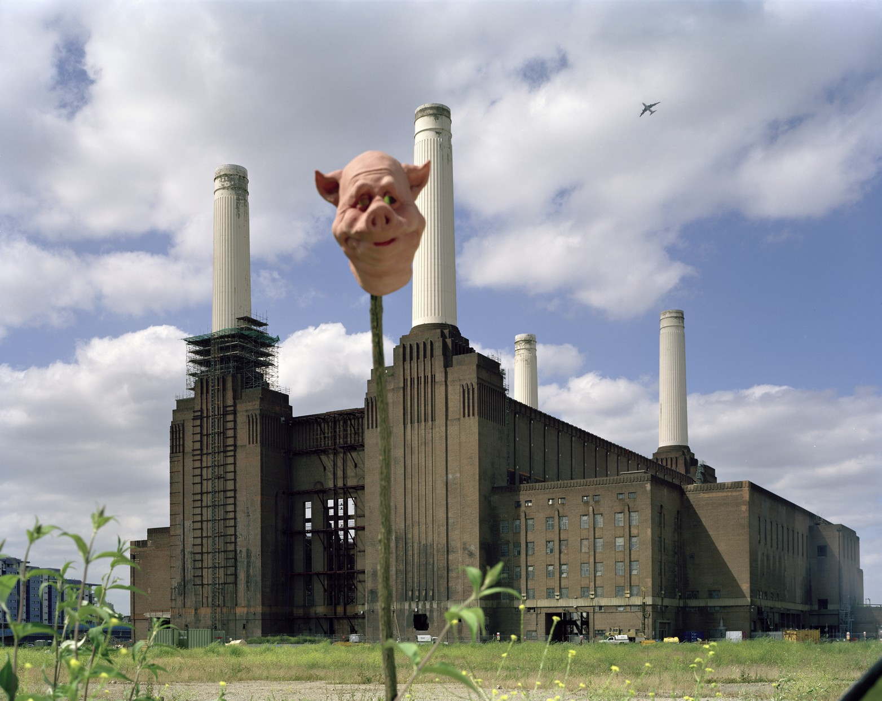

Giant Pigs, Pink Floyd and Organic Vegetables are the unlikely combination of
elements in Pump House Gallery’s latest art project with acclaimed German artist
Thomas Kilpper.

Pump House Gallery is delighted to be collaborating with Thomas Kilpper in developing an ambitious site-specific project in and outside of the gallery. This includes: the transformation of the gallery’s outside space into an allotment growing organic vegetables; a kitchen inside the gallery to prepare, cook and serve the resulting harvest to visitors; a giant pig sculpture made using trees cut down in Battersea Park; a series of photographic works in collaboration with Battersea Power Station and a new sound track fusing Pink Floyd with popular 1940’s war time songs.

Kilpper’s projects often respond to the socio-political context of a location, playfully interweaving local histories, global issues and his own political beliefs. For this project he has taken a keen interest in the rich and complex history of Battersea Park and its surrounding environment. In particular researching the period when the park was transformed into allotments and a pig farm during World War II, as well as the story behind the making of the iconic cover for Pink Floyd’s ‘Animals’ LP, which involved a giant inflatable pig flying over Battersea Power Station. Through exploring these past episodes Kilpper makes allusions to the present situation in Iraq.

Thomas Kilpper was born in Germany in 1956 and has received international critical acclaim for his dynamic and inventive practice. He has developed a number of important projects nationally and internationally, including The Ring, Orbit House, London 2000 in partnership with South London Gallery; Al Hissan, The Jenin Horse, Jenin, Palestine 2003; Ulrike Meinhof, Berlin 2004; Agenda 2010, Berlin 2005 and has been commissioned to make a new work for Momentum 2006: Nordic Festival of Contemporary Art. END

For more information, images or to arrange interviews please contact:
Sandra Ross on 020 7350 0523, sross@wandsworth.gov.uk

Pump House Gallery, Wandsworth Borough Council, Battersea Park, London SW11 4NJ
Tel: 020 7350 0523, Fax: 020 7228 9062, Email: pumphouse@wandsworth.gov.uk
www.wandsworth.gov.uk/gallery

