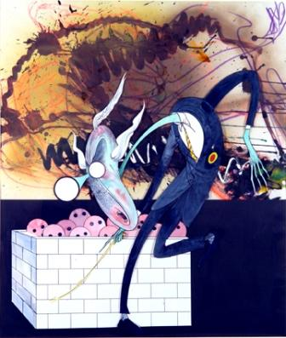
Scarfe on The Wall
Limited Edition Print Box Set
by
Gerald Scarfe

Eight individually signed, exhibition quality artist prints - 36pp collector’s monograph, signed by Roger Waters – 300 unit limited-edition, priced £1,195 – published by Gloria – July 2008

- Scarfe on the Wall is an authorised box set of eight individually-signed prints of Gerald Scarfe’s images for Pink Floyd’s multi-platinum selling album The Wall, including two newly commissioned artworks by Gerald Scarfe revisiting The Wall imagery two-and-a-half decades later
- The box set also contains a unique monograph featuring early illustrations and working drawings for The Wall, as well as a rare new interview with Gerald Scarfe. Each book will be individually signed by Pink Floyd founder member Roger Waters
- Strictly limited to an edition of 300 signed and numbered sets
- With highly collectible publications including Pelé, Superyacht and New York, Gloria reinforce their position as market-leader in the luxury, limited-edition ‘big books’, now with art collectibles as part of Gloria’s limited-edition business.

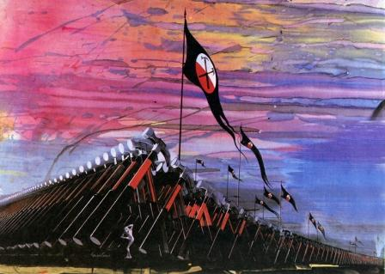
Gerald Scarfe is an internationally renowned illustrator and cartoonist, whose award-winning work has featured in newspapers and magazines, in the theatre, on television and on film, for forty years. However it was Scarfe’s collaboration with rock legend Roger Waters and the musical icons Pink Floyd that was to produce the most enduring musical multi-media concept in rock history and one that resulted in a 19 million-unit selling double album and later, a feature film directed by Sir Alan Parker.

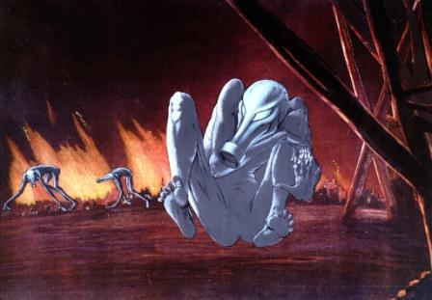
Originally commissioned by Pink Floyd to produce a series of animated sequences for the band’s Wish You Were Here tour, Scarfe went on to design the album art, tour animation sequences and models for Pink Floyd’s 1979 multi-platinum selling album The Wall. Scarfe was also seminal to the later feature film, where he contributed a 15-minute animated sequence and various other visual elements. The unforgettable imagery that Scarfe created, including the characters of ‘Pink’ and ‘Teacher’ endure as an intrinsic part of Pink Floyd’s visual identity and this work – partnering Scarfe and Waters, ranks among the most powerful and visceral concepts ever in the history of rock.

Gloria’s SCARFE ON THE WALL: Limited Edition Print Box Set is a celebration of this creativity.

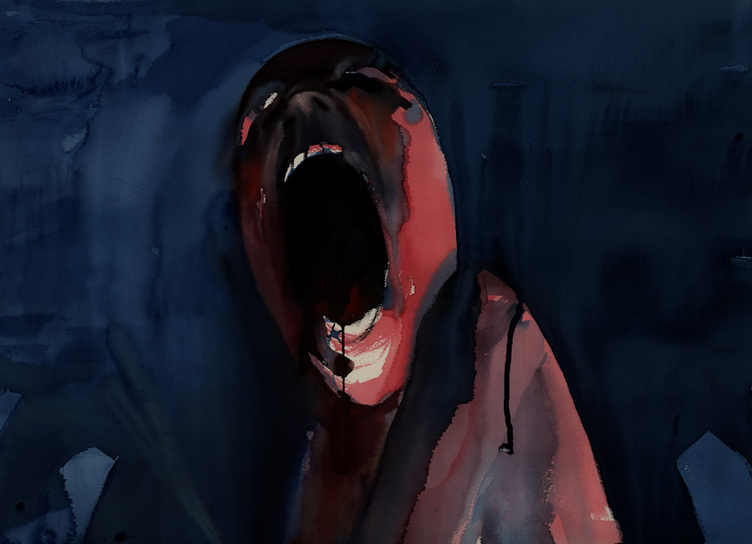
The eight images in this box set have been individually selected by Gerald Scarfe and Roger Waters from their collaboration on The Wall. The artworks are presented as exhibition-quality prints, each numbered and hand signed by the artist. Similarly, the box set’s illustrated companion volume, which features unique visual material of “The Wall” as it evolved and photographs of key team members, has also been individually signed by Waters, a rare commercial participation from him on a project of this kind.

Ovais Naqvi, CEO of Gloria, says, ‘The Wall is perhaps the greatest ‘big concept’ idea ever executed in rock. It’s a unique statement for us to be part of this. There’s nothing bigger in music than Floyd’.

For further information please contact Digby Halsby on
020 7590 8909 or email Digby.Halsby@midaspr.co.uk

